2.63: a) 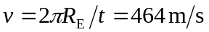
b)
c) Let c be the speed of light, then in one second light travels a distance 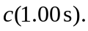 The number of times around the earth to which this corresponds is 